**Ansible**

* Install ansible:
  + Checking version:

* + Installing ansible using pip3.11:

* Inventory file and simple collections:









* Simple hello world playbook:



* Ansible role:

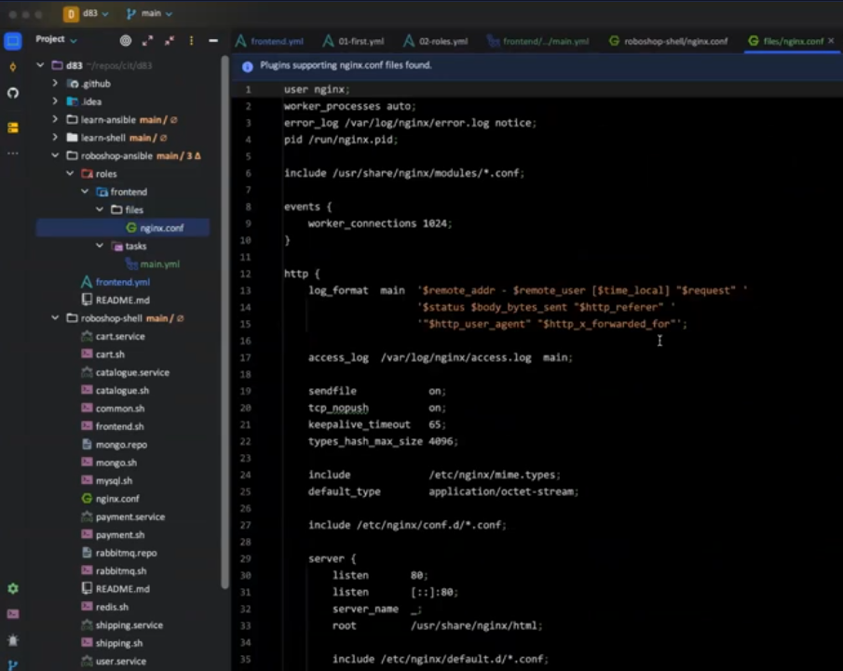

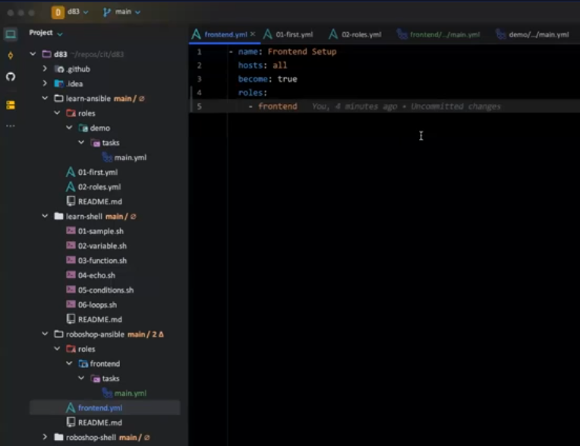

* Variables:
  + Order of variables:

* + Play and task level variables:

* + Role level variables:

* + Extra variables from command line:

* Including a task:

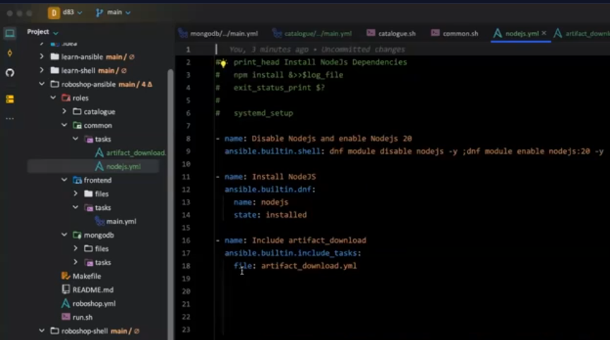

* To see the list of hosts in the inventory file:

* + Hosts in a group:

* Variables in ansible:

* Ansible facts:

* Registering and using a variable:

* Conditions in ansible:

* + Converting string to int:

* Conditionals using tags:

* Error handling:

* Templating:

* + With template:





* Encrypting password using ansible vault:

* Encrypting a file using ansible vault:

